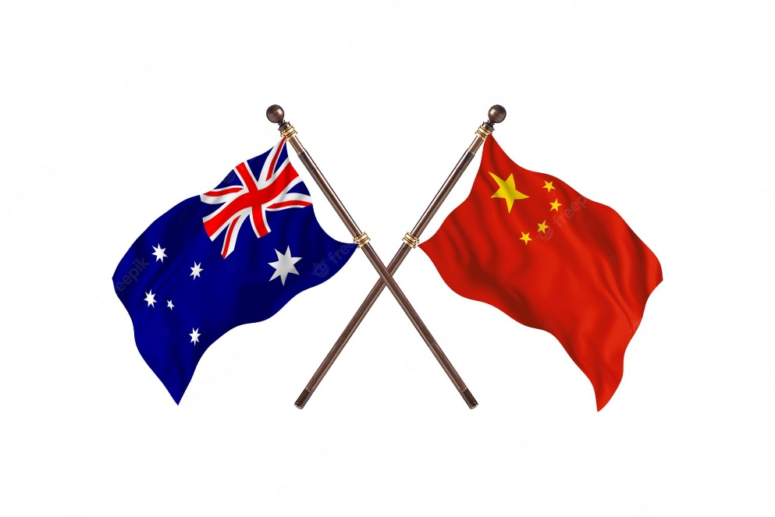
Australia & China
- Australia is a representative democracy which means parliament is given power through elections to act on behalf of citizens
- Two of the fundamental considerations that make up Australian democracy are:
  - Rule of law - the law is supreme and applied equally to all
  - The separation of powers - our political system is separated into branches which balance and provide checks on each other
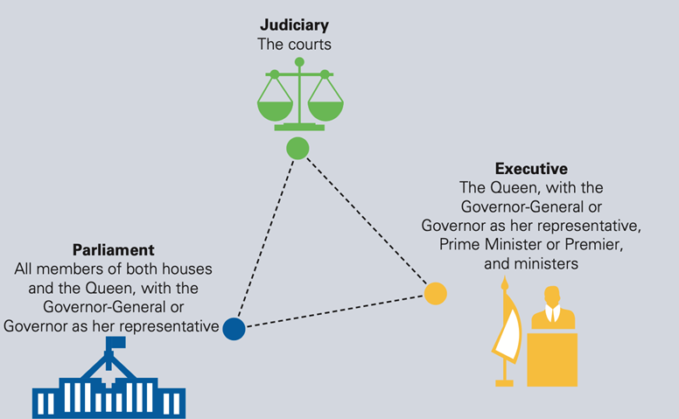

Democratic ideals and features of Australian representative democracy
- A modern democracy allows and provides the means of open political participation
  - People are able to contribute to the political system by voting, forming political parties and organisations, and assembling and protesting peacefully
  - Free and fair elections are held regularly
  - House of Representatives: lower house of Parliament which represents the majority of citizen votes
  - Courts: independent from influence by the legislative and executive branches
  - Basic rights are protected through the Constitution, legislation or parliamentary statutes, international agreements, conventions and court resolutions
People’s Republic of China
- China has a unitary communist government system – a unitary system is one in which the central government holds nearly all of the power.
- China is also an oligarchy, because only one group, the Communist Party of China, has control of the government
- The government has 3 branches, however there is no true separation of powers in China
- The communist republics: Single-party state where the people’s rights and freedoms are strictly controlled
- The People’s Republic of China was established in 1949 under the autocratic rule of Mao Zedong, leader of the Chinese Communist Party (CCP).
- While the country’s official name suggests that people hold the political power in China, the reality is somewhat different.
- The CCP strictly controls life within the country.
- China’s head of state is the president (currently Xi Jinping), who is selected by the National People’s Congress (NPC) for five-year terms.
- A two-term limit has been abolished, effectively allowing the president the position for life. China’s constitution describes its system as ‘democratic centralism’.
- Citizens over 18 can vote every five years, but only for regional congresses.
- These provincial congresses then elect representatives to the 3000-strong Congress, which convenes for two weeks of the year to approve legislation.
- Citizens have few parties to vote for; the dominant CCP not only controls the eight smaller parties, but must vet any of their candidates.
- The NPC selects the judiciary, which is recommended to conform to the principles and values of the CCP.
- Most judicial officials are CCP members.
- Individual rights and freedoms are rarely protected in the Chinese state, because the nation’s authority comes first.
- The Chinese Constitution does state that power belongs to the people, that all are equal, and all have the right to private property, freedom of speech, press, assembly and association.
- Yet this contrasts with the wider limitations on people within the country.
- For example, the CCP controls all Chinese media. Many social media sites that Australians enjoy are blocked in China, such as Facebook, Twitter and YouTube.
- Freedom of religion is allowed, unless it interferes with the purposes, aims and goals of the CCP.
- The country is criticised for its treatment of groups such as the Falun Gong, Uighur Muslims and Tibetan Buddhists.
- Those considered undesirable, or critical of the central government, are often imprisoned and sent to re-education camps.
- Even within the justice system, trials are often closed to the public, and many suspected of crimes are held in detention before charges are laid, without access to lawyers.

